**Market Analysis in Banking Domain**

**Project 3**

**Analysis tasks to be done-:**

1. Load data and create a Spark data frame

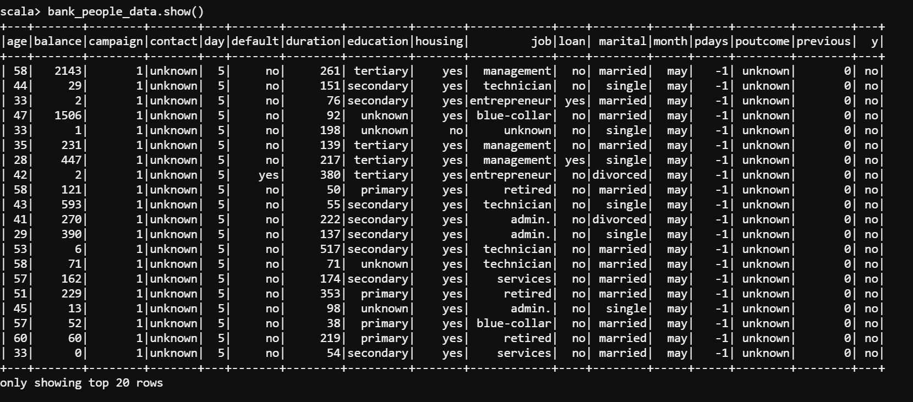

1. Give the maximum, mean, and minimum age of the average targeted customer

Maximum age of the average targeted customer:

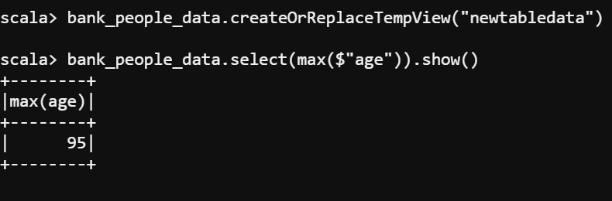

Average age of the targeted customer:

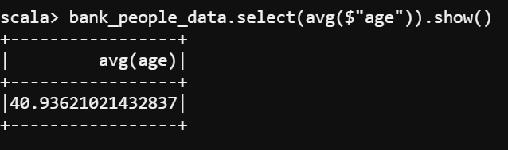

Minimum age of the targeted customer:

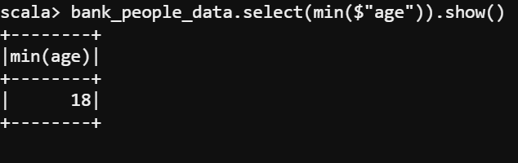

1. Check the quality of customers by checking average balance, median balance of customers

Average balance of customers:

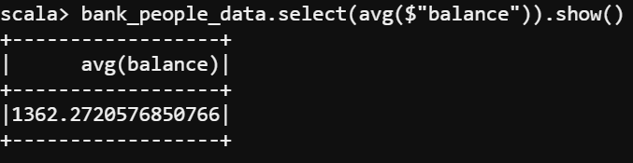

Median balance of customers:

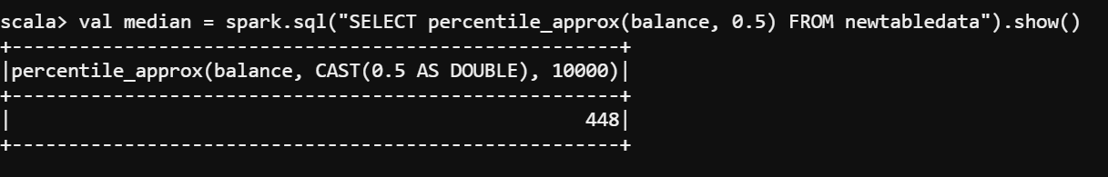

1. Check if age matters in marketing subscription for deposit

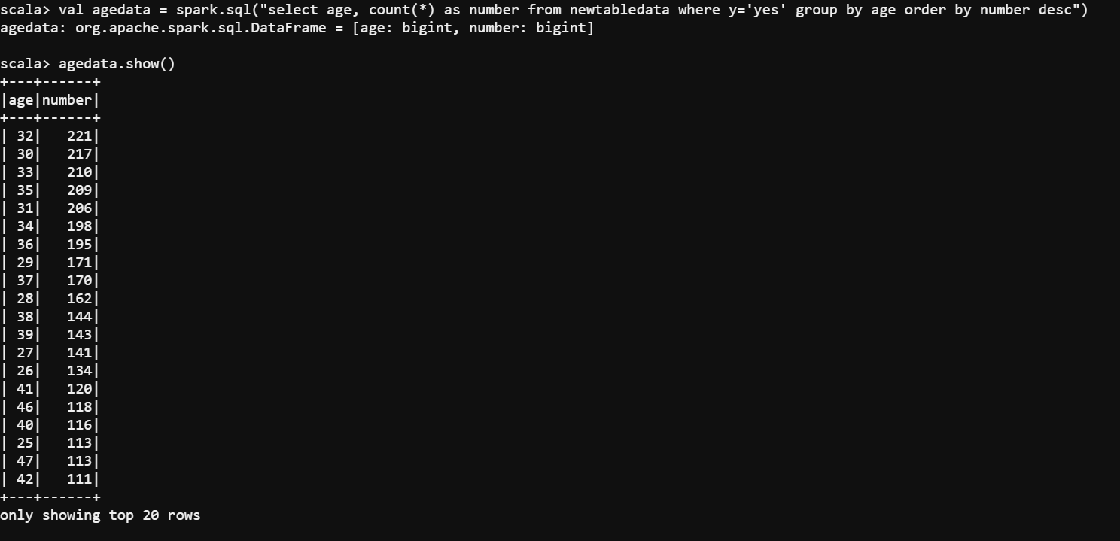

4. Check if marital status mattered for a subscription to deposit

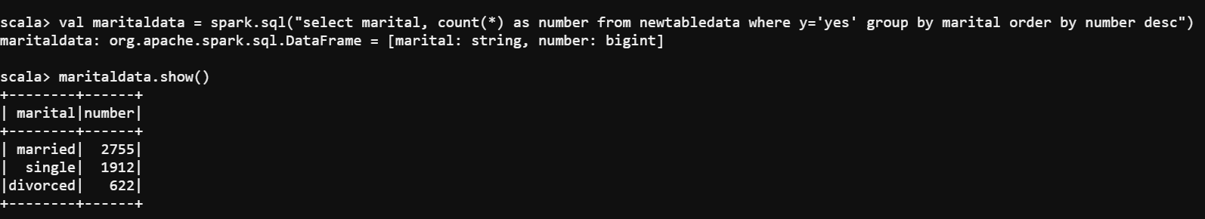

1. Check if age and marital status together mattered for a subscription to deposit scheme

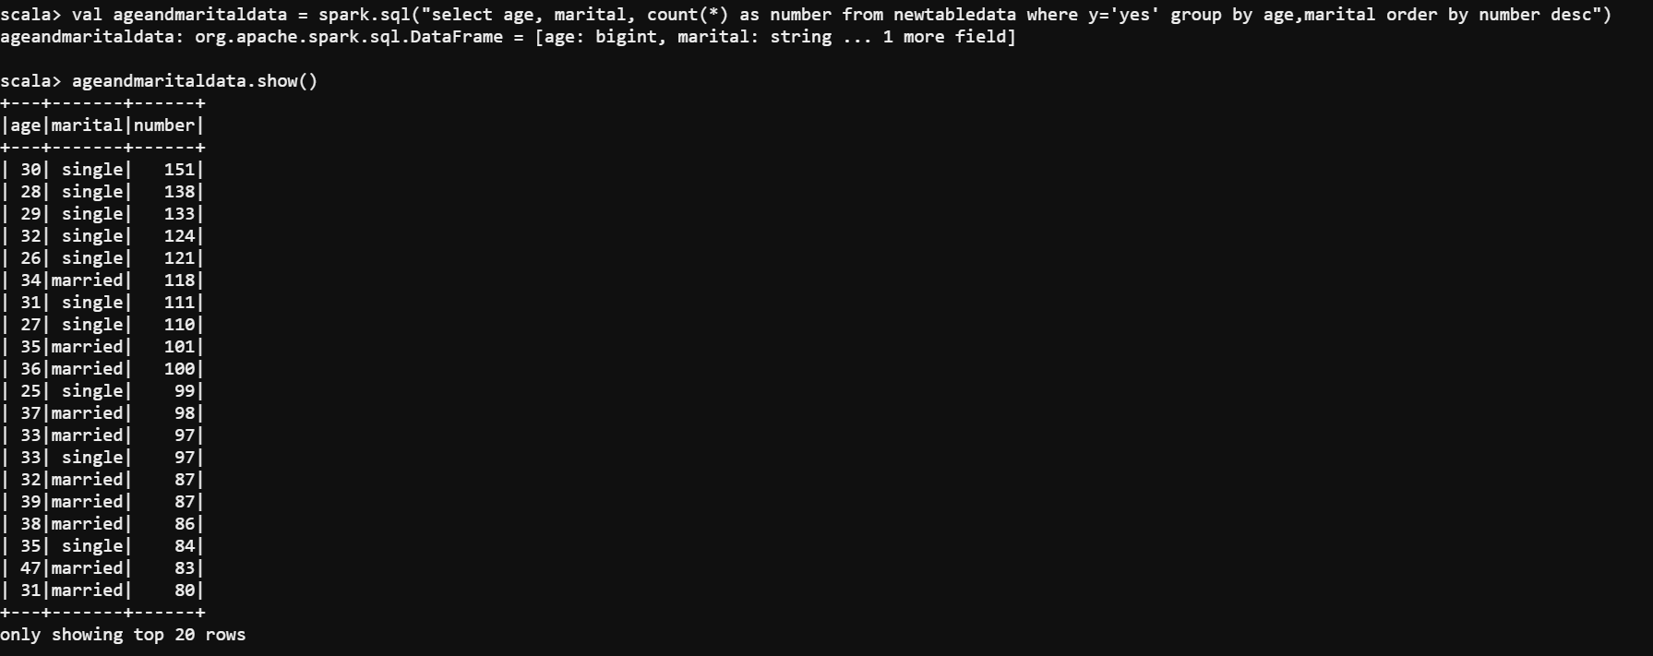

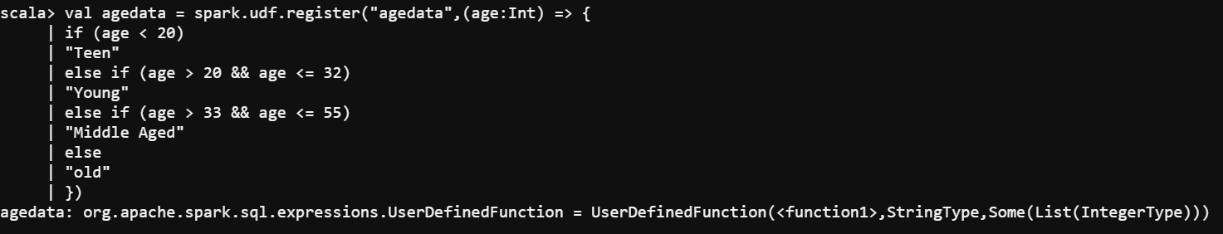

1. Do feature engineering for the bank and find the right age effect on the campaign

Step 1: Replacing the old age column with the new age column

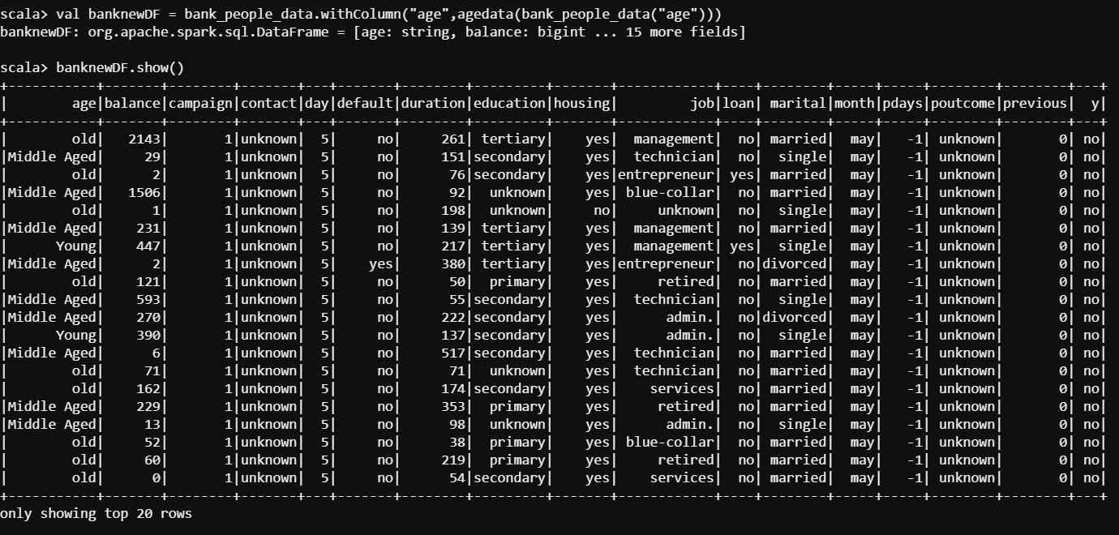

Step 2: Finding out the age group that has the most subscriptions

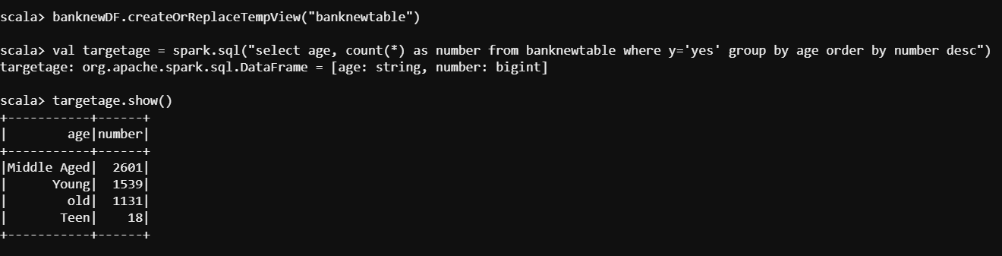

Step3: String Indexer Pipelining



Step 4: Model Fitting



Step 5: Assignment of generated value of index of the column by feature engineering

